Checklist for Server Preparation after Installation

1. Disable CTRL+ALT+Del

Edit the control-alt-delete.conf file & put the comment at the beginning of the following line to avoid reboot from these keyboard keys.

“/etc/inittab” inittab is no longer used when using systemd

1) Create symlink to /dev/null to avoid reboot from these keyboard keys

ln -sf /dev/null /etc/systemd/system/ctrl-alt-del.target

To check changes symlink after using above command

[root@RHEL7 ~]# ll /etc/systemd/system/ctrl-alt-del.target

lrwxrwxrwx 1 root root 9 Jan 22 16:23 /etc/systemd/system/ctrl-alt-del.target -> /dev/null

2. SFTP Also enable banner

- Add below entry to /etc/ssh/sshd_config

AllowUsers root sha sqladmin

2) And add following line in the file /etc/issue

Create a new file as following /etc/issue” and add below entries.
---------------
W A R N I N G
---------------
Access to this System/Device is restricted to authorized personnel only. Unauthorized access to this system is forbidden.
Disconnect IMMEDIATELY if you are not an authorized user!
This System/Device including all related equipment, network devices (specifically including Internet access), other resources are provided only for authorized use.
All computer systems may be monitored to ensure that their use is authorized.
Uses of this system, authorized or unauthorized, constitutes consent to monitoring of this system.
Unauthorized use may subject you to criminal prosecution.
Evidence of any such unauthorized use collected during monitoring may be used for administrative, criminal or other action.

3) Only keep below mentioned MACs, Key Exchange algorithms & Ciphers enabled by adding in /etc/ssh/sshd_config

Ciphers chacha20-poly1305@openssh.com,aes128-ctr,aes192-ctr,aes256-ctr,aes128gcm@openssh.com,aes256-gcm@openssh.com kexalgorithms curve25519-sha256,curve25519-sha256@libssh.org,ecdh-sha2-nistp256,ecdh-sha2nistp384,ecdh-sha2-nistp521,diffie-hellman-group-exchange-sha256,diffie-hellman-group16sha512,diffie-hellman-group18-sha512,diffie-hellman-group14-sha256 macs umac-64-etm@openssh.com,umac-128-etm@openssh.com,hmac-sha2-256etm@openssh.com,hmac-sha2-512-etm@openssh.com,hmac-sha1-etm@openssh.com,umac64@openssh.com,umac-128@openssh.com,hmac-sha2-256,hmac-sha2-512,hmac-sha1

Check with: egrep "^Banner|^Protocol|^AllowUsers|^Ciphers|^kexalgorithms|^macs" /etc/ssh/sshd_config ;

5) Enable Date and Time in History Command

1) Add HISTTIMEFORMAT='%d/%m/%y %T' in /etc/profile file

# echo 'HISTTIMEFORMAT="%F %T "' >> /etc/profile
# source /etc/profile

2) Check using below command

# history

6) Run the Activity Account Tool

1) Edit the /etc/cron.d/sysstat to run activity accounting tool for every 1 minute instead of 10 minutes.

Default line comment it

*/10 * * * * root /usr/lib64/sa/sa1 1 1

And add below line
*/1 * * * * root /usr/lib64/sa/sa1 1 1

7) Time Out to Run the OS

1) Edit the grub.conf file to boot the kernel if server supports that and time-out to 3 sec.

Specific information about Grub.conf

Default timeout as below line following file comment it /etc/default/grub #GRUB_TIMEOUT=5

Changed timeout to

GRUB_TIMEOUT=3

Run below mentioned command after changes

# grub2-mkconfig -o /boot/grub2/grub.cfg

Check with: grep -i timeout /boot/grub2/grub.cfg

8) To switch between the runlevels, you should type the following commands:

Run server to run level 3 after reboot (command line):

# ln -sf /usr/lib/systemd/system/multi-user.target /etc/systemd/system/default.target

OR the easy way

systemctl set-default multi-user.target

Check with: ll /etc/systemd/system/default.target
lrwxrwxrwx. 1 root root 41 Jan 22 19:37 /etc/systemd/system/default.target -> /usr/lib/systemd/system/multi-user.target

9) Enable ARP Packet Filtering and TCP syn cookies

Add the following line at end of /etc/rc.d/rc.local.

echo 1 > /proc/sys/net/ipv4/conf/all/arp_filter echo 1 > /proc/sys/net/ipv4/tcp_syncookies
echo 1 > /proc/sys/net/ipv4/tcp_tw_recycle

Also run the same below commands.

echo 1 > /proc/sys/net/ipv4/conf/all/arp_filter echo 1 > /proc/sys/net/ipv4/tcp_syncookies echo 1 > /proc/sys/net/ipv4/tcp_tw_recycle

Check with: cat /proc/sys/net/ipv4/conf/all/arp_filter /proc/sys/net/ipv4/tcp_syncookies /proc/sys/net/ipv4/tcp_tw_recycle

10) Service to run at Startup

Only enable below mentioned services that needs to be run on OS startup.

To check services:

systemctl list-unit-files --type service | grep enabled

To disable service:

systemctl disable service_name

To enable service:

systemctl disable service_name

abrt-ccpp.service | enabled
abrt-oops.service | enabled
abrt-vmcore.service | enabled
abrt-xorg.service | enabled
abrtd.service | enabled
auditd.service | enabled
crond.service | enabled
dbus-org.freedesktop.NetworkManager.service | enabled
dbus-org.freedesktop.nm-dispatcher.service | enabled
getty@.service | enabled
irqbalance.service | enabled
kdump.service | enabled
microcode.service | enabled
NetworkManager-dispatcher.service | enabled
NetworkManager.service | enabled
rngd.service | enabled
rsyslog.service | enabled
smartd.service | enabled
sshd.service | enabled
sysstat.service | enabled
systemd-readahead-collect.service | enabled
systemd-readahead-drop.service | enabled
systemd-readahead-replay.service | enabled
tuned.service | enabled

11) Custom System Monitoring Tool

1] Copy loadavgmonitor to /home/sha from below path

\\dumpserver.kotakseconline.com\allbackups\$Previous_Date\admin_stuff\Repository\Centos7\loadavg monitor
e.g:- \\dumpserver.kotakseconline.com\allbackups\2015-0702\admin_stuff\Repository\Centos7\loadavgmonitor

cd /home/sha/loadavgmonitor; chmod 755 *.sh *.pl

Add the below line into /etc/rc.local

/home/sha/loadavgmonitor/loadavgmonitor.sh > /home/sha/loadavgmonitor/loadavgmonitor.sh.err 2>&1 &

2] Copy Serveralertv2 to /home/sha from below path
\\dumpserver.kotakseconline.com\allbackups\$Previous_Date\admin_stuff\Repository\Centos7\ServerAl ert\serveralertv2
e.g:- \\dumpserver.kotakseconline.com\allbackups\2015-07-
02\admin_stuff\Repository\Centos7\ServerAlert\serveralertv2

cd /home/sha/serveralertv2/; chmod 755 *.sh *.pl

Add the below line into /etc/rc.local
su -l sha --command='/home/sha/serveralertv2/serveralertv2.sh <<SERVER NAME>>' > /home/sha/serveralertv2/serveralertv2.log 2>&1 &

12) Edit the /etc/rc.local

- And also copy “serverrebootstatus” into the /home from below path

\\dumpserver.kotakseconline.com\allbackups\$Previous_Date\admin_stuff\Repository\Centos7\serverreboo tstatus
e.g:- \\dumpserver.kotakseconline.com\allbackups\2015-0702\admin_stuff\Repository\Centos7\serverrebootstatus

- Put the following lines into /etc/rc.local to run the script which is the below mentioned path.

/home/serverrebootstatus/serverrebootstatus.sh >> /home/serverrebootstatus/serverrebootstatus.err 2>&1 &

- Change permisions

chmod 755 *.sh *.pl

This is for, when server will get reboot and get it up, it will give the status of the server.

13) Copy Aide Script for Check System Logs.

1) Install aide

# yum install aide

2) Copy aide folder from below mention location to /home/

\\dumpserver.kotakseconline.com\allbackups\$Previous_Date\admin_stuff\Repository\Centos7\AIDE\aide

e.g:- \\dumpserver.kotakseconline.com\allbackups\2015-07-02\admin_stuff\Repository\Centos7\AIDE\aide

3) Copy aide.conf Script from below mention location to /etc/

\\dumpserver.kotakseconline.com\allbackups\$Previous_Date\admin_stuff\Repository\Centos7\AIDE\aide.c onf

e.g:- \\dumpserver.kotakseconline.com\allbackups\2015-07-

02\admin_stuff\Repository\Centos7\AIDE\aide.conf

4) Change permisions in /home/aide

cd /home/aide; chmod 755 *.sh *.pl

5) Add in crontab

01 00 * * * /home/aide/aidecheck.sh

Run the script and check the logs for errors

14) Copy Nmon Log rotation script.

1) Copy nmonrotate folder from below mention location to /home

\\dumpserver.kotakseconline.com\allbackups\admin_stuff\application\nmonrotate

15) Enable compress option in /etc/logrotate.conf by uncomment the “compress”

1) Change rotate from 4 week to 52 Week in /etc/logrotate.conf

Default line comment it

# keep 4 weeks worth of backlogs # rotate 4

- And add below line

# keep 4 weeks worth of backlogs rotate 52

- Uncomment compress as below:

# uncomment this if you want your log files compressed compress

This is for compress logs of server for 52 Weeks

16) Disable Security Enhanced Linux by the following command.

1) To disable selinux comment below line in the file /etc/sysconfig/selinux

#SELINUX=enforcing

2) And below line

SELINUX=disabled

After reboot the server check selinux status by executing below command:

Output should be as below with following command sestatus

[root@localhost ~]# sestatus SELinux status: disabled

17) Block access to all accounts to login from anywhere other than specific machines

- Add the following line to /etc/pam.d/sshd file

account required pam_access.so

- Comment the following line to /etc/pam.d/system-auth file

#password requisite pam_cracklib.so try_first_pass retry=3

- Add the following line to /etc/pam.d/system-auth file

password requisite pam_cracklib.so try_first_pass retry=3 minlen=12 difok=3 dcredit=-1 ucredit=-1 lcredit=-1 ocredit=-1

- Add the following line to /etc/security/access.conf file

+:ALL:cron

-:root:ALL EXCEPT 172.24.3.229 172.24.3.234 172.24.3.235 10.6.102. 10.7.102. ksecdt004060.ksl.com ksecdt005620.ksl.com ksecdt000469.ksl.com 10.6.32. 10.7.32.

-:sqladmin:ALL EXCEPT 172.24.3.225 172.24.3.234 172.24.3.235235 10.6.102. 10.7.102. ksecdt004060.ksl.com ksecdt005620.ksl.com ksecdt000469.ksl.com 10.6.32. 10.7.32.

18) Copy ntpclient to /etc/cron.d / from below mentioned path

\\dumpserver.kotakseconline.com\allbackups\admin_stuff\Repository\Centos5\ntpclient\LiveServer

# cat /etc/cron.d/ntpclient
*/5 * * * * root /usr/sbin/ntpdate -u 10.6.4.210 > /dev/null 2>&1

19) Add nmon in crontab

1) Copy nmon rpm from below path into /root/temp

\\dumpserver.kotakseconline.com\allbackups\admin_stuff\application\nmon\
\nmon_tool\nmon_tool_all\nmon-14g-1.el7.rf.x86_64.rpm

Create nmonreport folder

mkdir /home/sha/nmonreport

Install RPM

rpm –ivh nmon-16m-1.el8.x86_64

change ownership of /home/sha/nmonreport to sha

chown -R sha.sha /home/sha/nmonreport

chmod 755 /bin/nmon

Add below entry in crontab

00 00 * * * su -l sha --command='nmon -f -m /home/sha/nmonreport -s30 -c2880'

20) Badblocks Check (DON’T RUN ON VM SERVER)

Check for badblocks using following command :

badblocks -v -v -c 1 /dev/sda

Options :--
-v --- Verbose Mode ,
-v --- Verbose Mode,
-c --- Count the Number of Blocks
1 --- Count from the Start Block

/dev/sda --- Check the partition for Badblocks

Run it in the screen command as follows

screen --- It is a full screen window manager that will create physical terminal between the processes in the same shell where you can use the program as you normally would.

Screen 0: bash
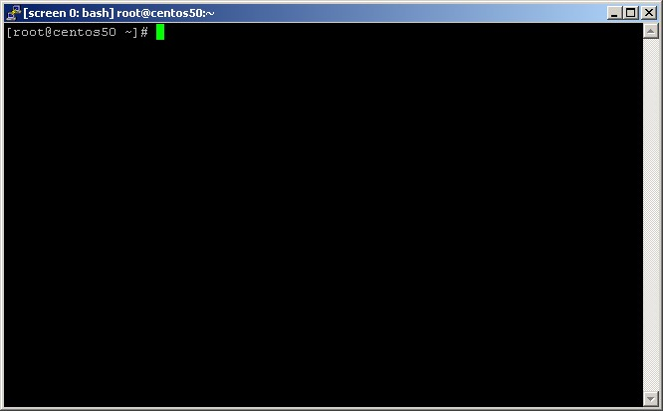
screen

t
hen new window manager will open.

Give the command

badblocks -v -v -c 1 /dev/sda badblocks -v -v -c 1 /dev/sdb

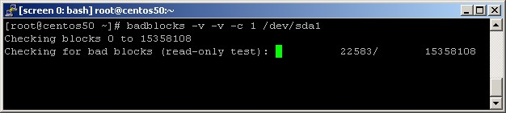

For detaching the screen press CTRL+A, CTRL+D

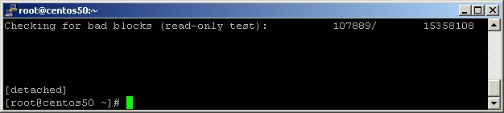

For attaching the screen give the command,

screen –r

21) To create a 5GB /tmp partition, remember to choose right file system marked in red (ext4 or xfs)

# dd if=/dev/zero of=/tmpfs bs=1024 count=5010000
# mkfs.xfs /tmpfs or
# mkfs.ext4 /tmpfs
# mkdir /tmp.new
# mount -o loop,noexec,nosuid,nodev,rw /tmpfs /tmp.new
# cp -av /tmp/* /tmp.new
# umount /tmp.new
# mount -o loop,noexec,nosuid,nodev,rw /tmpfs /tmp ; chmod 1777 /tmp

Edit fstab and add

/tmpfs /tmp xfs defaults,loop,nodev,nosuid,noexec 0 0

Or

/tmpfs /tmp ext4 defaults,loop,nodev,nosuid,noexec 0 0

22) Disable TLS Older than TLSv1.2

Change SSLProtocol in /etc/httpd/conf.d/ssl.conf to below for disabling older TLS versions.

SSLProtocol all -TLSv1.1 -TLSv1 -SSLv3 -SSLv2

After changing, verify with httpd -t & restart http service.

23) Enable Server Signing in for SAMBA

Add below line in /etc/samba/smb.conf

server signing = mandatory

Verify with testparm & reload the samba service with systemctl reload smb.service

